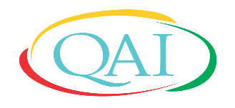
Change Adapt Improve
Quality and Accreditation Institute
Centre for Education & Training

Certified Internal Auditor Course
(Virtual)

Registration Form
Course Name: Certified Internal Auditor Course on ART/IVF Accreditation Standards
Date: |  | Photo
Venue: QAI Secretariat (Virtual Platform)

Name Dr./Mr./Ms. [in Capital letters) _________________________________________
Designation____________________________________________________________
Name and Address of Organisation__________________________________________________
_______________________________________________________________________
City ______________________________________Pin Code________________________
Mobile_______________________________Email_________________________________

(Signature of the Participant)

Course Name | For India (Rs.) | For countries in LMIC (as per the World Bank classification) (USD) | For countries other than LMIC (USD)
Certified Internal Auditor Course on ART/IVF Accreditation Standards | 5000 + GST@18% | 70 + GST@18% | 100+ GST@18%

Candidates are requested to pay the fee after confirmation mail.
Completed form may please be sent to shivi@qai.org.in

Last Date to apply:
Certified Internal Auditor Course on ART/IVF Accreditation Standards: 18 August 2020

